

**College of Life Sciences and Agriculture**

**Department of Biological Sciences**

Rudman and Spaulding Halls 46 College Road  
Durham, NH 03824-2617 USA

Durham, NH 03824-xxxx

14-April-2024

Dear Editorial Board,

Please below our CRediT author statement for the manuscript: “**Assessing the need for temporary fishing closures to support sustainability for a small-scale octopus fishery**”, by Sophie Wulfing, Ahilya Sudarshan Kadba, Merrill Baker-Médard, and Easton R. White.

Author Contributions:

**Sophie Wulfing:** Conceptualization, Methodology, Software, Formal Analysis, Writing – Review & Editing

**Ahilya Sudarshan Kadba:** Data Curation, Writing – Original Draft, Writing – Review & Editing

**Mez Baker-Médard:** Validation, Writing – Original Draft, Writing – Review & Editing, Funding acquisition, Supervision, Project administration

**Easton R. White:** Methodology, Validation, Writing – Original Draft, Writing – Review & Editing, Funding acquisition, Supervision, Project administration

Sincerely,

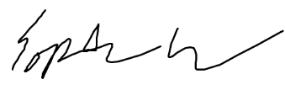

Sophie Wulfing

Masters Student

Department of Biological Sciences

University of New Hampshire